FES System Calibration through EMG

**Objective:** The aim of this study is to analyse the feasibility of recognising gestures generated with electrical stimulation through the analysis of M-wave features.

**Methods:** After establishing 3 gestures (wrist extension, index finger extension and wrist flexion), 100 repetitions (40, 30, 30 respectively) were recorded with a stimulation of 40 Hz at an amplitude of 14 mA.

In this study, 7 EMG channels distributed in the proximal forearm area (following the Rehyb electrode design) were used. The acquisition systems used were the Mega Neurone and the ACQ 2.0 connected with splitters (to record at the same time from both systems). The sampling rate for the Mega Neurone was 5Khz. The sampling rate for the ACQ 2.0 was 1KHz.

From each gesture, for each channel, the M-wave amplitude was extracted as an input feature to the classifier, which was tested by applying cross-validation techniques.

**EMG Acquisition System:** Mega NeurOne (<https://www.bittium.com/medical/bittium-neurone>) with EMG commercial electrodes and ACQ 2.0.

**Stimulation FES:** Rehyb Stim 1.5 with Spider electrodes

## Stimulation Cathodes and EMG location.

The placement of the EMG electrodes is illustrated in Figure 1.

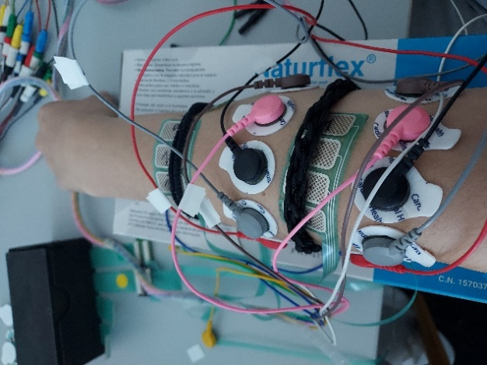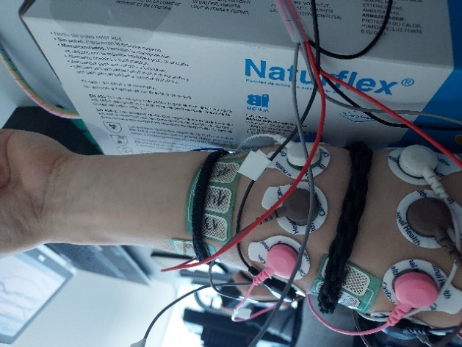

**Figure 1: Electrodes location for the experiment. 7 EMG channels.**

Three cathodes were used for stimulation: cathode 7 (wrist extension), cathode 12 (index finger extension) and cathode 15 (wrist flexion). The location of these cathodes is illustrated in Figure 2.

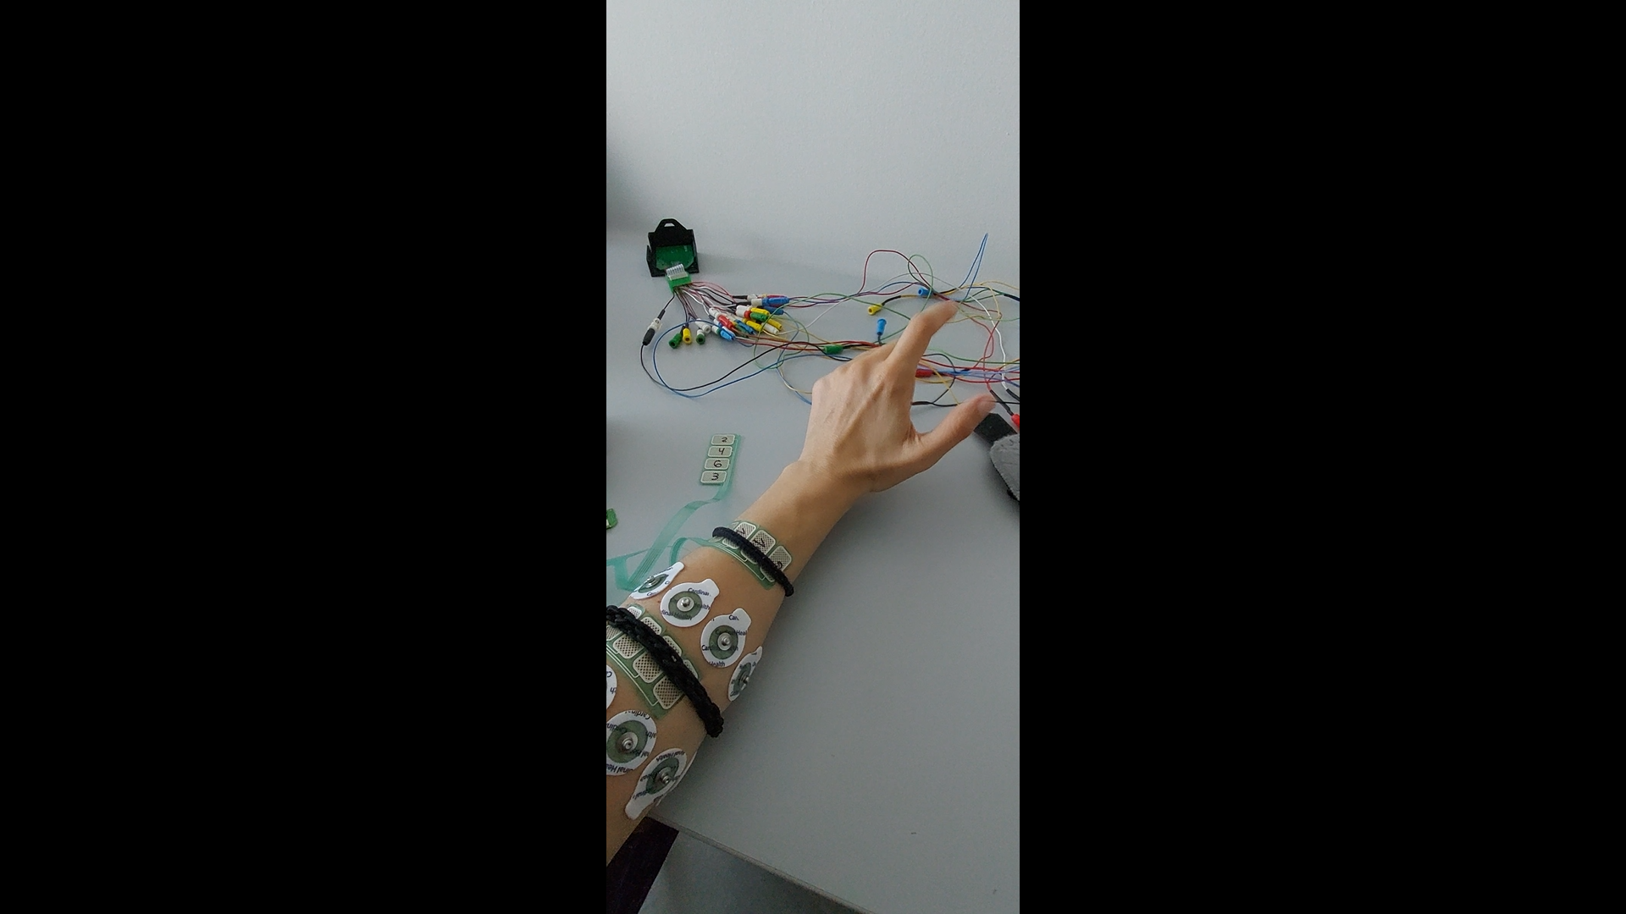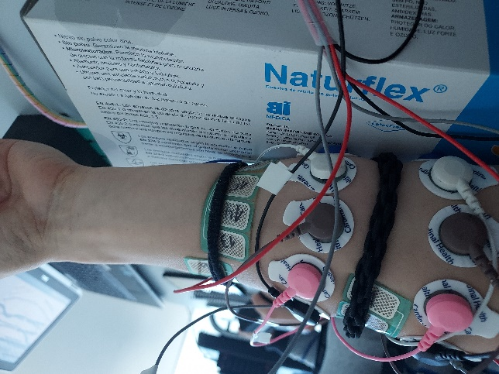

**Figure 2: Cathode 7 (left), Cathode 12 (middle) and Cathode 15 (right) location.**

## Feature Extraction.

As input to the classifier, the M-wave amplitude was extracted for each channel. The M-wave amplitude was calculated as the difference between the maximum peak and trough between 13 and 21 milliseconds after stimulation of the mean signal.

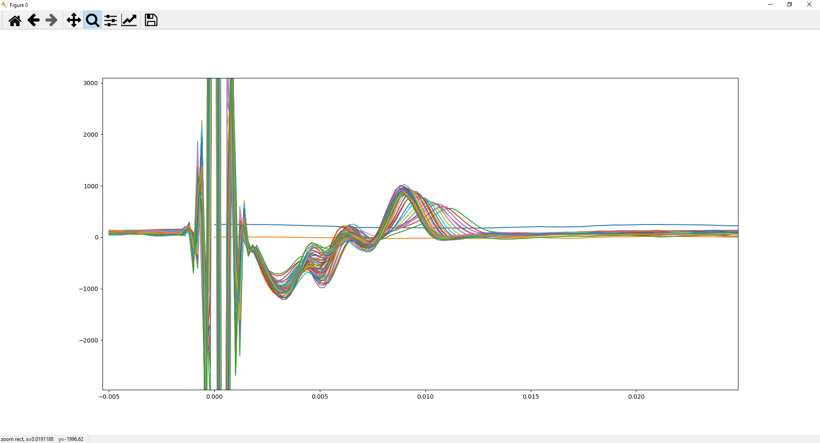

**Figure 3: Mega Neurone: Post-stimulation signals generated at a frequency of 40Hz and 16mA with the channel 1 of the wrist extension gesture.**

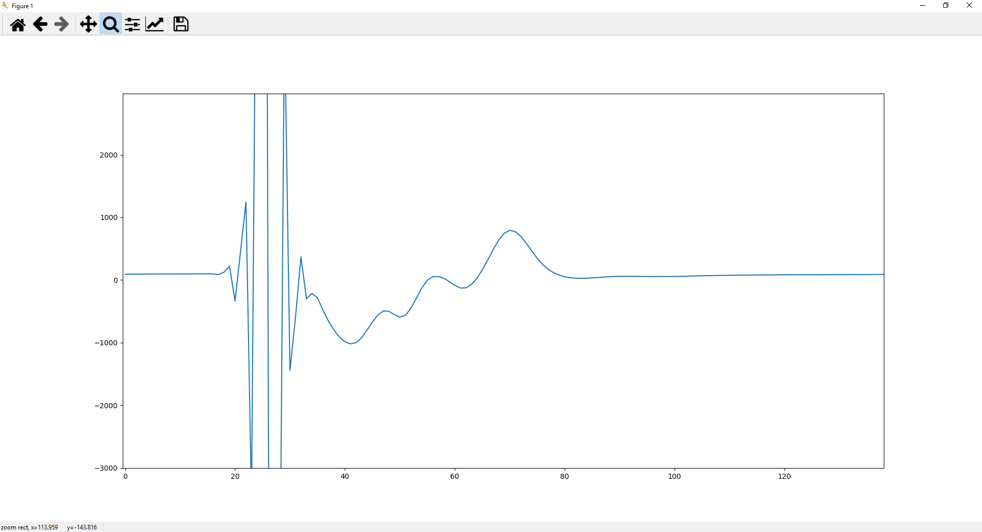

**Figure 4: Mega Neurone: Mean of all the M-Wave of the channel 1 in the wrist extension gesture.**



A

**Figure 5: Mega Neurone: Amplitud of the M-Wave of the channel 1 in the wrist extension gesture.**

## Classification

Fifteen models were evaluated for the classification (see table 1).

|  |  |
| --- | --- |
| Classification Model | Parameters |
| Linear Discriminant Analysis |  |
| Logistic Regression |  |
| Ridge Classifier | Alpha: 0.1, 0.2, 0.3, 0.4, 0.5, 0.6, 0.7,..1.0 |
| SGD Classifier | Max iter: 1000, tol: 1e-3 |
| Passive Aggressive Classifier | Max iter: 1000, tol: 1e-3 |
| KNN Classifier | K from 1 to 21 |
| Decision Tree Classifier |  |
| Extra Tree Classifier |  |
| SVM Classifier | Kernel: lineal and poly ad rbf |
| Bayes Classifier |  |
| Ada Boost Classifier | Num trees: 100 |
| Bagging Classifier | Num trees: 100 |
| Random Forest Classifier | Num trees: 100 |
| Extra Trees Classifier | Num trees: 100 |
| Gradient Boosting Classifier | Num trees: 100 |

**Table 1: Evaluated models with their parameters.**

The recorded gestures were divided into training data (80%) and test data (20%).

Cross-validation (folds=10) was applied to the training data and the following results were obtained (Table 2) with the ranking (Table 3).

|  |  |
| --- | --- |
| Mega Neurone | ACQ 2.0 |
| >LDA: 1.000 (+/-0.000)  >logistic: 1.000 (+/-0.000)  >ridge-0.1: 0.963 (+/-0.113)  >ridge-0.2: 0.963 (+/-0.113)  >ridge-0.3: 0.963 (+/-0.113)  >ridge-0.4: 0.963 (+/-0.113)  >ridge-0.5: 0.963 (+/-0.113)  >ridge-0.6: 0.963 (+/-0.113)  >ridge-0.7: 0.963 (+/-0.113)  >ridge-0.8: 0.963 (+/-0.113)  >ridge-0.9: 0.963 (+/-0.113)  >ridge-1.0: 0.963 (+/-0.113)  >sgd: 0.988 (+/-0.037)  >pa: 0.964 (+/-0.055)  >knn-1: 0.988 (+/-0.037)  >knn-2: 0.988 (+/-0.037)  >knn-3: 0.988 (+/-0.037)  >knn-4: 0.988 (+/-0.037)  >knn-5: 0.988 (+/-0.037)  >knn-6: 0.988 (+/-0.037)  >knn-7: 0.988 (+/-0.037)  >knn-8: 0.975 (+/-0.050)  >knn-9: 0.988 (+/-0.037)  >knn-10: 0.963 (+/-0.080)  >knn-11: 0.963 (+/-0.080)  >knn-12: 0.963 (+/-0.080)  >knn-13: 0.963 (+/-0.080)  >knn-14: 0.963 (+/-0.080)  >knn-15: 0.963 (+/-0.080)  >knn-16: 0.963 (+/-0.080)  >knn-17: 0.963 (+/-0.080)  >knn-18: 0.963 (+/-0.080)  >knn-19: 0.963 (+/-0.080)  >knn-20: 0.950 (+/-0.083)  >cart: 0.963 (+/-0.080)  >extra: 0.988 (+/-0.037)  >svml: 1.000 (+/-0.000)  >svmp: 0.963 (+/-0.057)  >svmr0.1: 0.889 (+/-0.104)  >svmr0.2: 0.963 (+/-0.080)  >svmr0.3: 0.975 (+/-0.075)  >svmr0.4: 0.988 (+/-0.037)  >svmr0.5: 0.988 (+/-0.037)  >svmr0.6: 0.988 (+/-0.037)  >svmr0.7: 0.988 (+/-0.037)  >svmr0.8: 0.988 (+/-0.037)  >svmr0.9: 0.988 (+/-0.037)  >svmr1.0: 0.988 (+/-0.037)  >bayes: 0.988 (+/-0.037)  >ada: 0.976 (+/-0.047)  >bag: 0.975 (+/-0.075)  >rf: 0.988 (+/-0.037)  >et: 0.988 (+/-0.037)  >gbm: 0.988 (+/-0.037) | >LDA: 0.878 (+/-0.075)  >logistic: 0.976 (+/-0.047)  >ridge-0.1: 0.878 (+/-0.075)  >ridge-0.2: 0.878 (+/-0.075)  >ridge-0.3: 0.878 (+/-0.075)  >ridge-0.4: 0.878 (+/-0.075)  >ridge-0.5: 0.878 (+/-0.075)  >ridge-0.6: 0.878 (+/-0.075)  >ridge-0.7: 0.878 (+/-0.075)  >ridge-0.8: 0.878 (+/-0.075)  >ridge-0.9: 0.878 (+/-0.075)  >ridge-1.0: 0.878 (+/-0.075)  >sgd: 0.876 (+/-0.097)  >pa: 0.867 (+/-0.123)  >knn-1: 0.975 (+/-0.050)  >knn-2: 0.926 (+/-0.099)  >knn-3: 0.939 (+/-0.083)  >knn-4: 0.901 (+/-0.075)  >knn-5: 0.865 (+/-0.101)  >knn-6: 0.865 (+/-0.101)  >knn-7: 0.878 (+/-0.109)  >knn-8: 0.878 (+/-0.109)  >knn-9: 0.890 (+/-0.100)  >knn-10: 0.890 (+/-0.100)  >knn-11: 0.878 (+/-0.109)  >knn-12: 0.890 (+/-0.115)  >knn-13: 0.890 (+/-0.115)  >knn-14: 0.890 (+/-0.115)  >knn-15: 0.890 (+/-0.115)  >knn-16: 0.890 (+/-0.115)  >knn-17: 0.890 (+/-0.115)  >knn-18: 0.878 (+/-0.109)  >knn-19: 0.878 (+/-0.109)  >knn-20: 0.878 (+/-0.109)  >cart: 0.963 (+/-0.057)  >extra: 0.867 (+/-0.110)  >svml: 0.963 (+/-0.057)  >svmp: 0.865 (+/-0.084)  >svmr0.1: 0.743 (+/-0.165)  >svmr0.2: 0.878 (+/-0.094)  >svmr0.3: 0.878 (+/-0.109)  >svmr0.4: 0.890 (+/-0.115)  >svmr0.5: 0.890 (+/-0.115)  >svmr0.6: 0.890 (+/-0.115)  >svmr0.7: 0.890 (+/-0.115)  >svmr0.8: 0.890 (+/-0.115)  >svmr0.9: 0.890 (+/-0.115)  >svmr1.0: 0.890 (+/-0.115)  >bayes: 0.940 (+/-0.078)  >ada: 0.656 (+/-0.065)  >bag: 0.975 (+/-0.050)  >rf: 0.964 (+/-0.055)  >et: 1.000 (+/-0.000)  >gbm: 0.939 (+/-0.083) |

**Table 2: Evaluated models results training and testing with the training dataset.**

|  |  |
| --- | --- |
| Mega Neurone | ACQ 2.0 |
| Rank=1, Name=svml, Score=1.000 (+/- 0.000)  Rank=2, Name=logistic, Score=1.000 (+/- 0.000)  Rank=3, Name=LDA, Score=1.000 (+/- 0.000)  Rank=4, Name=gbm, Score=0.988 (+/- 0.037)  Rank=5, Name=et, Score=0.988 (+/- 0.037)  Rank=6, Name=rf, Score=0.988 (+/- 0.037)  Rank=7, Name=bayes, Score=0.988 (+/- 0.037)  Rank=8, Name=svmr1.0, Score=0.988 (+/- 0.037)  Rank=9, Name=svmr0.9, Score=0.988 (+/- 0.037)  Rank=10, Name=svmr0.8, Score=0.988 (+/- 0.037) | Rank=1, Name=et, Score=1.000 (+/- 0.000)  Rank=2, Name=logistic, Score=0.976 (+/- 0.047)  Rank=3, Name=bag, Score=0.975 (+/- 0.050)  Rank=4, Name=knn-1, Score=0.975 (+/- 0.050)  Rank=5, Name=rf, Score=0.964 (+/- 0.055)  Rank=6, Name=svml, Score=0.963 (+/- 0.057)  Rank=7, Name=cart, Score=0.963 (+/- 0.057)  Rank=8, Name=bayes, Score=0.940 (+/- 0.078)  Rank=9, Name=gbm, Score=0.939 (+/- 0.083)  Rank=10, Name=knn-3, Score=0.939 (+/- 0.083) |

**Table 3: Top 10 classifiers.**

Using the testing dataset for the test the results are shown in the Table 4.

|  |  |
| --- | --- |
| Mega Neurone | ACQ 2.0 |
| LDA 1.0  logistic 1.0  ridge-0.1 1.0  sgd 1.0  pa 1.0  knn-1 1.0  cart 0.9523809523809523  extra 0.9047619047619048  svml 1.0  svmp 1.0  svmr1.0 1.0  bayes 1.0  ada 1.0  bag 1.0  rf 1.0  et 1.0  gbm 1.0 | LDA 0.8095238095238095  logistic 0.8571428571428571  ridge-0.1 0.8095238095238095  sgd 0.8095238095238095  pa 0.7142857142857143  knn-1 0.9047619047619048  cart 1.0  extra 0.8095238095238095  svml 0.9047619047619048  svmp 0.6666666666666666  svmr1.0 0.7619047619047619  bayes 0.8095238095238095  ada 0.6190476190476191  bag 0.9523809523809523  rf 0.9047619047619048  et 0.9523809523809523  gbm 0.9523809523809523 |

**Table 4: Evaluated models results training with the training dataset and testing with the testing dataset.**

## Conclusions

The present study has shown that classification of gestures using M-wave features may be of interest. Despite the fact that the ACQ 2.0 system recorded at 1Khz compared to the 5Khz of the Mega Neurone system, the results obtained by both were very high, reaching 100% accuracy in several classifiers.

Despite the good results, it should be noted that the set of gestures used was very small, and it is necessary to extend the corpus in order to analyse how the classifiers are shared.